**Friarwood Surgery Newsletter**

Newsletter 2: November 2024

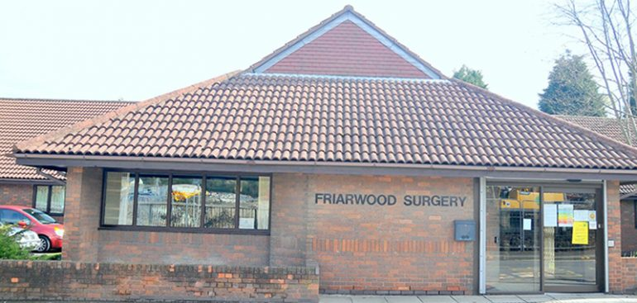

|  |
| --- |
| **WE’RE WORKING HARD TO KEEP YOU WELL** |
| In the 3 months between September and November 2024   * 28,855   Attended appointments   * 658   Did not attend appointments   * 124   New registrations   * 613   home visits   * 13,272   Total patients registered   * 8,605   Online consultations |
|  |

**Welcome to our Practice Newsletter**

We are pleased to send you another edition of the Friarwood Surgery newsletter.

This contains practice news, updates and wider primary care messages and announcements, which you can expect to receive on a quarterly basis.

We will continue to let you know of any upcoming events, or ways you can get involved in activities and how you can make a positive impact at your Practice.

Your feedback on this newsletter is welcomed, and we would also be delighted to hear of any ideas and content you would like to see in a future edition. You can send these to [Wyicb-wak.friarwoodppg@nhs.net](mailto:Wyicb-wak.friarwoodppg@nhs.net)

Look at our data

Every quarter, we will release what we call our GP infographics, which aim to give you an insight into the goings on at your local practice.

The latest infographics can be found on the right-hand side of this page, we hope you find these infographics insightful.

**A day in the life of a PPG member**

Hello. I’m Rebecca and I’m a member of the Patient Participation Group here at Friarwood. I became a member when I first joined the practice a few years ago. At that time, we met virtually due to Covid restrictions but now meet in person in the surgery at 6pm every 3 months for an hour or so. I decided to join the group as I have had chronic kidney disease for the past 20 years, more recently resulting in dialysis and then a transplant that has been, unfortunately, full of complications. I have needed frequent appointments and treatment at the hospital and support from Friarwood too. As a regular user of the NHS, I felt I had plenty of experience of being a patient and wanted to give back in some way to a service that has invested so much time and care into me personally.

The PPG consists of several Friarwood patients and staff, including the Practice Manager and a GP. We are given an agenda before each meeting and the minutes, and any agreed tasks are sent to us afterwards. The purpose of the PPG is for members to have an opportunity to voice their opinions about a variety of aspects of the surgery, from a patient’s perspective, to assist in improving health care provision, communication between the surgery and patients and the introduction of new services. The aims of the PPG are listed in more detail on the website along with the latest newsletter. The meeting often includes a speaker who explains about a service the surgery provides that we may not know the details about. A recent example of this was a Health and Well-being coach who really inspired us with her info about the ongoing and up and coming services available in supporting patients to reach their health goals. We are also kept up to date with staffing changes and new initiatives in the practice, such as the recently introduced call back function available when patients phone the surgery. Any extra services like the Flu vaccine Saturday clinics are also brought to our attention.

 It is well worth looking at the website, Facebook page and newsletter to keep up to date on any changes and the brilliant services Friarwood provides.

New members to the Patient Participation Group are always very welcome too. Next meeting is Wednesday January 8th 2025 at 6pm in the surgery.

Thank you

Rebecca



To register your interest in joining the group, please email your details to

Wyicb-wak.friarwoodppg@nhs.net

**Telephone System Update**



Our new cloud-based telephony system is fully up and running!

As you will be aware from previous correspondence, as part of the changes made to the GP contract last year – it was made a requirement for all GP practices to sign up to a fully cloud-based telephone system. As a practice, we decided to change to Smart IT as our provider.

Smart IT was approved by the NHS “Better Purchasing Framework” and is an accredited provider of advanced cloud-based GP telephone solutions. For those of you that have not called the surgery in a while, I am pleased to announce we added the “call back function”, we have experienced some challenges along the way.

The main driver for the change was to improve the experience for our patients by reducing the call waiting times with place-in-queue notifications, as well as giving our patients the option to request a call back, because we appreciate that not everyone has time to sit waiting for the telephone to be answered when we first open. We are confident that this new system has improved the appointment booking experience for our patients and we would be really interested to hear your thoughts

**Getting to Know Your Practice - Team News**

We are pleased to announce that we have welcomed Lauren to the practice nurse team. Lauren joined the team in November.

Dr Soman has now left Friarwood Surgery. After 16 years working with our team, he has moved on to pastures new overseas. He was a popular and caring GP, respected employer and esteemed partner, he will be greatly missed.

**Vaccination Programme – Update Covid, Flu & RSV Vaccine**

The covid and flu programme is now well under way.

Flu vaccines to 65 years and over, 1634 done at the practice Under 65 years with a medical condition, 520 given.

If you would like a flu vaccine, please get in touch, we still have plenty to offer our patients.

Covid vaccines have now ceased at the practice. You can still get one by calling 119 or going online <https://www.nhs.uk/nhs-services/covid-19-services/covid-19-vaccination-services/>

We have been unable to get hold of many patients due to incorrect contact numbers. If you have a mobile and you are not sure if we have the number, please get in touch and let us check.

**Day in the life of a Practice Nurse at Friarwood Surgery** 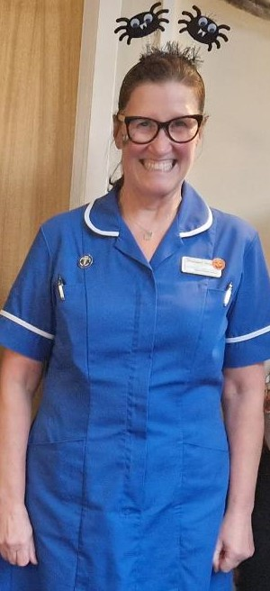

Lyndsey,

So, I have been a Practice Nurse for 33 years at Friarwood Surgery. I work 27 hours a week Wednesday 8:30am-6:30pm, Thursday 7:30am – 5:30pm and Friday 7:30am – 5:30pm. My days off are generally planned with my close family and friends.

My days at work generally start earlier, but that’s how I have always worked within my role. I like to get stocked, prepared, and ready for the day ahead. Catching up with emails, tasks and/or reviewing my appointments for that day.

My clinics are structured in blocks of time-allocated appointments so that I can effectively focus and manage the care that I give that individual patient.

An average day would include a morning session of cytology, asthma, and general duties appointments. There are some Long-Term Care appointments (or as the patient understands it, their annual check), which are in on that morning, that can include co-morbidities for diabetes, hypertension, chronic kidney disease, learning disabilities, mental health or COPD. Within that appointment they have their BP, pulse, exercise rating, diet, smoking history, alcohol consumption, mood, memory, depression status recorded, and blood taken for their medication review. Some co-morbidities need more questions and intervention. For example: diabetes will need foot checks, asthmatics will need inhaler technique, peak flow readings and an asthma plan made for them. They all have some variation of checks specific to each condition.

General duties are in multiples of 10 minutes and can be anything from dressings and wound checks, injections for testosterone, prostate cancer, endometriosis, shingles, contraception and pre-pregnancy vaccines.

I am ready for a coffee break, but I have my thermal cup prepared to drink as I work through the morning.

Nurse 1 or extra appointments are kept a close eye on by all the nursing team to ensure they are dealt with. Included in that list are urine dips/ACR’s, immunisation advice, specific nurse only appointments to make or I do put reminders on for me personally to follow up if I get time.

Some appointments do run over time, due to that patient wanting more advice/support. It can be overwhelming at times, but the patient/family member, I hope are grateful for the time I have given them. Generally, patients that are waiting are understanding for being called in late for their appointment.

If an emergency ECG has been requested for a patient with chest pain, we take a quick look at the nursing dynamics of the team, we can share the responsibility between our clinics to give that patient the care and attention they require. We keep the GP informed and if necessary, ensure they are observed before the paramedics/ambulance arrive.

Lunch is sometimes a quick one. I bring in my own usually. I enjoy a general chat and banter with whoever is in the staff room at the same time as me.

1pm the afternoon clinics start. Usually, asthma appointments that are for annual checks or follow-ups for patients that have had treatment change or recent exacerbations of their asthma. Then onto childhood immunisations, that consists of babies from 8,12,16 weeks old to 3 to 6 months of age. Parents/carers come in very apprehensive at times, but we try to maintain a model of support and motivation in telling mums, dads, and carers that they are doing the best for their child/children. Yes, it is upsetting but it is for us too. I fill in the ‘red book’ and record it on their notes so that it is seen to have been given. Preschool boosters (3-and-a-half-year-olds) are generally more aware of what is happening, so we kind of ‘bribe’ them by giving them a sticker and a bravery certificate to hopefully make them sit still whilst their mum, dad or carer gives them a big cuddle.

From there, I have a drink and move onto cervical screening (cytology) clinic. Appointments are 20minutes each. I have usually prepared the cytology history of the women that are booked in that morning before starting my day by looking on the CSMS site that shows me their smear/gynaecological history of that lady and it can then be recorded on Ardens and on her cytology form, prior to it being printed out.

When the last patient has finished, I start clearing up speculums, filling out cytology transport forms identifying that patient(s) and the samples are placed in transport bags ready for collection.

The end of my day does overflow most days. I need to get some overseas vaccinations and immunisation history on for two children that have recently registered with the surgery. Then I check all windows are closed, doors locked, keys in the safe in the nursing area, lights off and homeward bound.

“The days are never long enough, but the hours fly by, I say”.

I do feel privileged to be a part of Friarwood Surgery. I know we are doing the utmost to maintain a high standard of care. Hoping the patients and their families feel safe and supported.

My 33 years as a Practice Nurse is coming into its final chapter and I am retiring soon.

So, can I just say, my life as a Practice Nurse has been the best. I have worked alongside the best of the best and have been a part of an unbelievable team here at Friarwood Surgery.

The patients, their relatives, and families too, go without saying have made an enormous impression upon me, which I will not ever forget.

Love, Lyndsey xx

**Patient feedback from friends and Families**

The Friends and Family Test (FFT) is a short questionnaire which gives you the chance to provide feedback on the care and treatment you've received at our GP surgery. It also helps us to improve our services and see where we've done things right! The questions are answered anonymously which means you don’t have to give us any personal information. You can have a family member or carer help you complete the survey. You may receive the Friends and Family Test questions via text message following an appointment at the practice, or, you can fill in a paper form available in the patient waiting areas or from our reception desk

**July**

Doctors are always very efficient and explains everything thoroughly, also listens to what I am telling them. The receptionists are always helpful and friendly

The doctor was very reassuring and helped to put me at ease. He explained the procedure and what to do afterwards. He also answered any questions I asked. Totally supportive.

Excellent Service

**August**

Easy to book an appointment online. Quick friendly service at the surgery with no delays

I was seen on time, very helpful nurse

First appointment with Health Coach. Felt understood and the session was very enlightening.

**September**

Great reception and waiting areas. Attentive staff. Pleasant appointment experience. No issues at all. Thank you to all. I chose this surgery above others BECAUSE of the waiting room.

Very good nurse practitioner – good advice, professional but very compassionate and approachable

Super friendly phlebotomist, extremely competent and professional, a painless experience. Thank you

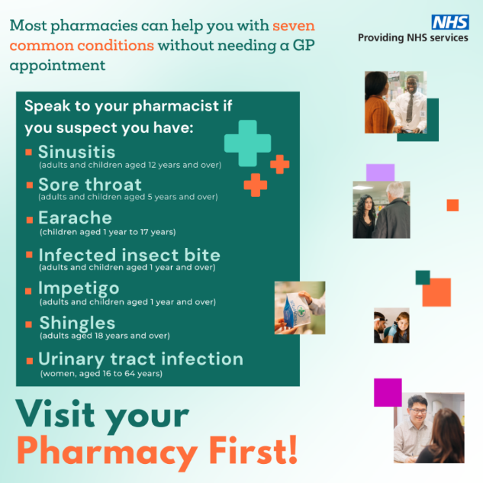**The Pharmacy First**

The Pharmacy First Scheme is available at most local pharmacies, you do not need an appointment to access this service.

They will help you with seven common conditions, including:

* Sinusitis
* Sore throat
* Earache
* Infected insect bites
* Impetigo
* Shingles
* Urinary tract Infections (in women)

**Health and Wellbeing Coach**

Health and wellbeing coaches support people to increase their ability to self-manage, motivation levels and commitment to change their lifestyle. They are experts in behaviour change and focus on improving health related outcomes by working with people to set personalised goals and change their behaviours. They work with people with physical and/or mental health conditions and those at risk of developing them.

Health and wellbeing coaches can be an effective intervention for people experiencing a range of long-term conditions, including respiratory, cardiovascular (including type 2 diabetes and hypertension) and stress/low mood. They can also support people with weight management, diet and increasing activity levels.

Below are some useful links from the health coach

Active 10 NHS App [https://www.nhs.uk/better-health/get-active/](https://gbr01.safelinks.protection.outlook.com/?url=https%3A%2F%2Fwww.nhs.uk%2Fbetter-health%2Fget-active%2F&data=05%7C02%7Cwyicb-wak.friarwoodppg%40nhs.net%7C6412479a914940599ff508dce77331e6%7C37c354b285b047f5b22207b48d774ee3%7C0%7C0%7C638639729137155298%7CUnknown%7CTWFpbGZsb3d8eyJWIjoiMC4wLjAwMDAiLCJQIjoiV2luMzIiLCJBTiI6Ik1haWwiLCJXVCI6Mn0%3D%7C0%7C%7C%7C&sdata=tlONc1eIxmEMd0MYq6rnJVW%2FWuyK2ksNjvvanfHDnVw%3D&reserved=0)

British Menopause Society <https://thebms.org.uk>

Every Mind Matters <https://nhs.uk/every-mind-matters/>

Other useful links

* [https://www.nhs.uk/mental-health/self-help/guides-tools-and-activities/five-steps-to-mental-wellbeing/](https://gbr01.safelinks.protection.outlook.com/?url=https%3A%2F%2Fwww.nhs.uk%2Fmental-health%2Fself-help%2Fguides-tools-and-activities%2Ffive-steps-to-mental-wellbeing%2F&data=05%7C02%7Cwyicb-wak.friarwoodppg%40nhs.net%7C6412479a914940599ff508dce77331e6%7C37c354b285b047f5b22207b48d774ee3%7C0%7C0%7C638639729137227594%7CUnknown%7CTWFpbGZsb3d8eyJWIjoiMC4wLjAwMDAiLCJQIjoiV2luMzIiLCJBTiI6Ik1haWwiLCJXVCI6Mn0%3D%7C0%7C%7C%7C&sdata=QofJHOPIgd2ojvMdgyJ8YfJOZpAJ9oqM5NCXVIPw42w%3D&reserved=0)​
* [https://selfhelp.cntw.nhs.uk/](https://gbr01.safelinks.protection.outlook.com/?url=https%3A%2F%2Fselfhelp.cntw.nhs.uk%2F&data=05%7C02%7Cwyicb-wak.friarwoodppg%40nhs.net%7C6412479a914940599ff508dce77331e6%7C37c354b285b047f5b22207b48d774ee3%7C0%7C0%7C638639729137248612%7CUnknown%7CTWFpbGZsb3d8eyJWIjoiMC4wLjAwMDAiLCJQIjoiV2luMzIiLCJBTiI6Ik1haWwiLCJXVCI6Mn0%3D%7C0%7C%7C%7C&sdata=E%2BrVJ7Bd4PCfK78vj77SY3tV5dnpUrRz3xyJgOxhbbs%3D&reserved=0)​
* [https://soundcloud.com/breathworks-mindfulness](https://gbr01.safelinks.protection.outlook.com/?url=https%3A%2F%2Fsoundcloud.com%2Fbreathworks-mindfulness&data=05%7C02%7Cwyicb-wak.friarwoodppg%40nhs.net%7C6412479a914940599ff508dce77331e6%7C37c354b285b047f5b22207b48d774ee3%7C0%7C0%7C638639729137268725%7CUnknown%7CTWFpbGZsb3d8eyJWIjoiMC4wLjAwMDAiLCJQIjoiV2luMzIiLCJBTiI6Ik1haWwiLCJXVCI6Mn0%3D%7C0%7C%7C%7C&sdata=Vlh2NjsNoY6qkc2hQFWT2ElkIjazmi1%2B5LOr1E%2FgFao%3D&reserved=0)​
* [https://self-compassion.org/](https://gbr01.safelinks.protection.outlook.com/?url=https%3A%2F%2Fself-compassion.org%2F&data=05%7C02%7Cwyicb-wak.friarwoodppg%40nhs.net%7C6412479a914940599ff508dce77331e6%7C37c354b285b047f5b22207b48d774ee3%7C0%7C0%7C638639729137287400%7CUnknown%7CTWFpbGZsb3d8eyJWIjoiMC4wLjAwMDAiLCJQIjoiV2luMzIiLCJBTiI6Ik1haWwiLCJXVCI6Mn0%3D%7C0%7C%7C%7C&sdata=0Kgx7gY%2FZONDg%2FyPLr9PjVlcZ0DQDkFuxjTL%2FUmQr4M%3D&reserved=0)
* [https://www.diabetes.org.uk/](https://gbr01.safelinks.protection.outlook.com/?url=https%3A%2F%2Fwww.diabetes.org.uk%2F&data=05%7C02%7Cwyicb-wak.friarwoodppg%40nhs.net%7C6412479a914940599ff508dce77331e6%7C37c354b285b047f5b22207b48d774ee3%7C0%7C0%7C638639729137305998%7CUnknown%7CTWFpbGZsb3d8eyJWIjoiMC4wLjAwMDAiLCJQIjoiV2luMzIiLCJBTiI6Ik1haWwiLCJXVCI6Mn0%3D%7C0%7C%7C%7C&sdata=mJgoISLyks6OMvIaJZPfkt1bdim5pbOmaZjZdjwsjaw%3D&reserved=0)
* [https://www.heartuk.org.uk/](https://gbr01.safelinks.protection.outlook.com/?url=https%3A%2F%2Fwww.heartuk.org.uk%2F&data=05%7C02%7Cwyicb-wak.friarwoodppg%40nhs.net%7C6412479a914940599ff508dce77331e6%7C37c354b285b047f5b22207b48d774ee3%7C0%7C0%7C638639729137322789%7CUnknown%7CTWFpbGZsb3d8eyJWIjoiMC4wLjAwMDAiLCJQIjoiV2luMzIiLCJBTiI6Ik1haWwiLCJXVCI6Mn0%3D%7C0%7C%7C%7C&sdata=hmLWVSBA8evSbBQ%2Be4J0RLHaHZ723ZQxgimwUpXEIoU%3D&reserved=0)
* [https://www.bhf.org.uk/](https://gbr01.safelinks.protection.outlook.com/?url=https%3A%2F%2Fwww.bhf.org.uk%2F&data=05%7C02%7Cwyicb-wak.friarwoodppg%40nhs.net%7C6412479a914940599ff508dce77331e6%7C37c354b285b047f5b22207b48d774ee3%7C0%7C0%7C638639729137341040%7CUnknown%7CTWFpbGZsb3d8eyJWIjoiMC4wLjAwMDAiLCJQIjoiV2luMzIiLCJBTiI6Ik1haWwiLCJXVCI6Mn0%3D%7C0%7C%7C%7C&sdata=CDF1bmKutESxt5%2B1c4xJFfioLByh35M9SKhjt053L3s%3D&reserved=0)

**Warm Spaces**

**Blood Pressure Checks**

We have a self-service blood pressure machine in the main waiting area, which can be used during our opening hours and takes no more than 5 minutes. This is a walk-in service with no appointment required.

**Patient Confidentiality**

Everyone 16 years or over needs to contact the surgery for their own results and medical information. Due to patient confidentiality, we cannot give information about any patients 16 years or over to anyone else, without prior permission

**Next of Kin:**

Do we have an emergency contact for you?

Let us know who your next of kin is so we have an up-to-date information on your records.

If you are unable to speak to the medical team due to illness or injury, the hospital or doctor may need to speak to a representative on your behalf.

If you are happy for someone to speak on your behalf, let a member of staff so we can log your consent.

**Help us keep your details up to date:**

To be able to communicate with patients quickly and efficiently we offer an SMS service to communicate various reminders, for example flu clinics, immunisation invitations and health advice. If you would like to be sent SMS reminders let the surgery know an updated mobile number when you next speak to them

Winter is here and what better way to stay warm, have a chat and a warm drink than going to a warm space.

Don’t struggle with the cold when you can’t afford the heating. Warm spaces are available around Pontefract and the surrounding area.

* Pontefract Library
* St Mary’s Community Centre
* The Urban Commune
* Malt Shovel Pontefract
* The Ancient Borough Arms
* Pontefract Methodist Church
* The Warm Room
* Hearts Collective

Click the link below for more details and other locations

[**www.warmwelcome.uk**](https://l.facebook.com/l.php?u=http%3A%2F%2Fwww.warmwelcome.uk%2F%3Ffbclid%3DIwZXh0bgNhZW0CMTAAAR3AkuJgpWfUHSd6_cc-UKIKw_mSIY4qRPFP0Gwn3gHov6J-2bL0GHTTA-w_aem_izVRB3Z6KAYgvSBthOqJtA&h=AT0ifvqYYasG58DrNWrk7CAjWLP47TU10RBRZRPLAaQazVGnMA9zIvJ7K7Ic2xK0S9J2tYUVACkj0mzkBF3ULGYfnAJosMYWm91F15X8K_-fjHsyU4nGMTc_QG_MrJ4t-w&__tn__=-UK-R&c%5b0%5d=AT0I8Iqt7wEgyAVLj87RQ4FQzeAdrhhmfksGjxXkip3AFMTgxS8ktw2eNYalCXbBg4ZZST36ApAwen3kLz-5wlRpmuQRtUW_xKYxQnFe_JHPitt6865duiv1pmhlsFDlVoX8LdHSoDlJU7zSB5Ns8OQmR40ar0AbAp-iQD5l7-t-M5bZlmXrkLDiD9p66J9AOlGh6Ud20SD32bqNC5X8qPsglFQ)

**Lumi Nova**

Lumi Nova supports children and young people to build confidence and learn lifelong skills to manage their worries through an intergalactic adventure game!

* For children 7 – 12 years old
* Supports mild to moderate fears, worries and anxiety
* Digital therapy through a fun mobile game (smartphone /tablet)
* Safe, effective and easy to use.



**Night OWLS**

Night Owls is a confidential support line for children and young people experiencing a mental health crisis at night 8pm to 8am

Call free: 0800 148 8244

Text: 079843 76950

Chat on: wynightowls.org.uk